**Clicking on “a” tag around it displays a dashed border**

**Description:**

When the user clicks on any “a” tag on the page around it a dashed border appears.

**Steps to reproduce:**

1. Open Firefox Web Browser

2. Go to flowing URL: <http://automationpractice.com/index.php>

3. Click on any “a” tag on page

**Expected result:**

User is redirected to the linked page without any visual change to the “a” tag we clicked

**Actual result:**

User is redirected to the page with the link, but clicking on the "a" tag appears a dashed border

**Priority:** Low

**Severity:** Low

**Repro rate:** 100%

**Enviroment:** Production

**Screenshot:**

1.

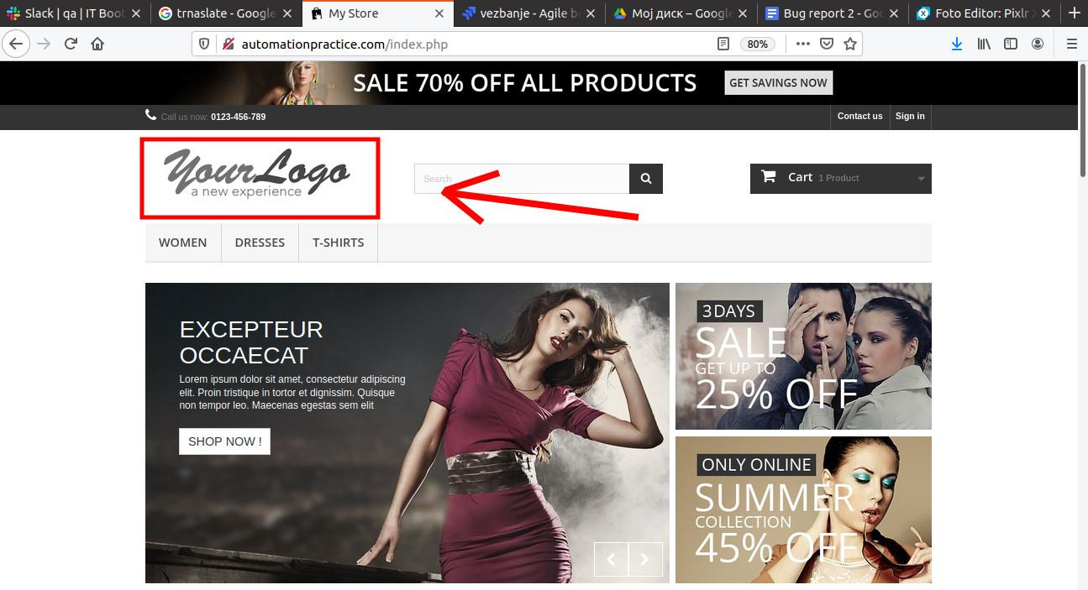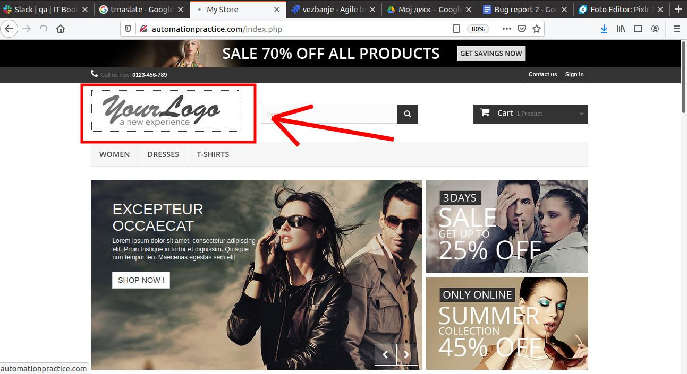

2.